TYNE CENTRAL COUNCIL – 200 CLUB

November 2024 RESULTS
1st (£50) 56
M Hutchinson St Cuthbert’s, Kenton
B Atkinson All Saints, Lanchester
Tom MacKie St Charles, Gosforth

2nd (£25) 49
M Scott Our Lady of Lourdes, Wallsend
Joan Gillingham All Saint’s, Lanchester

Thank you for your continued support.

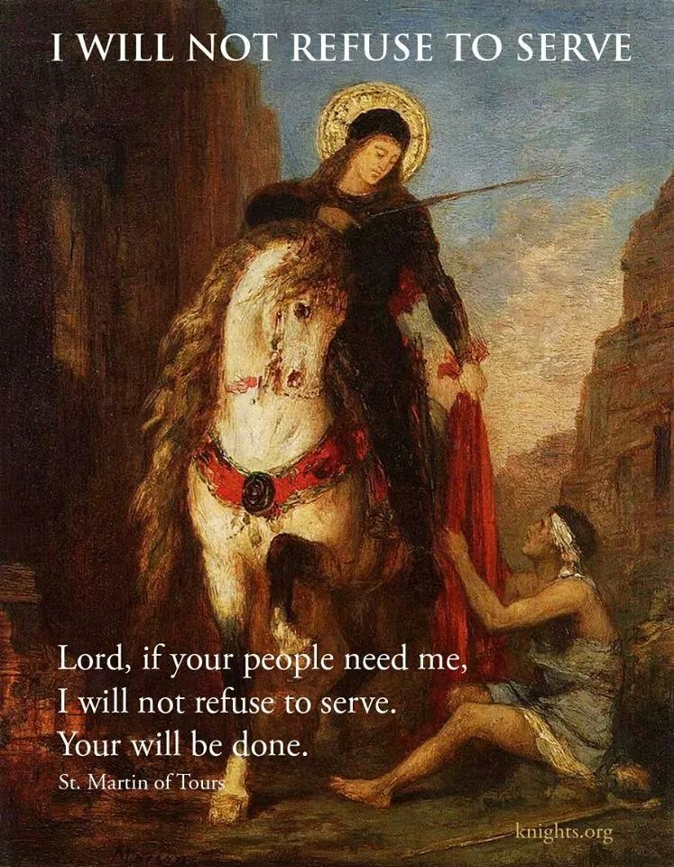

St Martin de Tours - Feast Day 11th November
Birth: 316 or 336 Death: 397
Patron Saint of poor, soldiers, tailors and winemakers

