TYNE CENTRAL COUNCIL – 200 CLUB

November 2025 RESULTS

1st (£50) 152
Margaret Kirby St Mary & St Wilfred, Bishop Auckland
Margaret Salkeld St Joseph Birtley

2nd (£25) 54
M. McCabe All Saints, Lanchester
Maureen Doyle Durham Martyrs St. Godric’s
Thank you for your continued support.

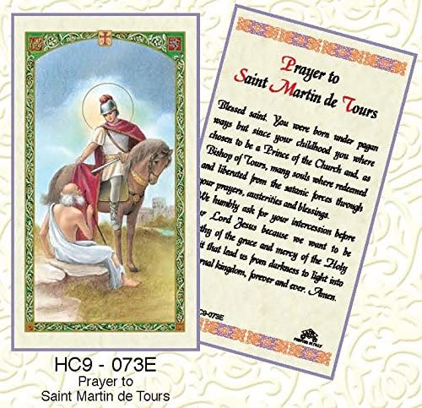

.
St Martin de Tours - Feast: 11th November
also known as Martin the Merciful, was the third Bishop of Tours. He has become one of the most familiar Christian Saints in France and is generally depicted giving half his cloak to a beggar.

