TYNE CENTRAL COUNCIL – 200 CLUB
RESULTS – September 2026 DRAW

1st (£50) No 75
Mary Sim Sacred Heart & St Cuthbert’s, Amble
Frances Thompson St Joseph’s Birtley

2nd (£25) No 198
Kate Edwards All Saints, Lanchester
Pauline Percival Our Lady of Lourdes Wallsend

With many thanks for your continued support.

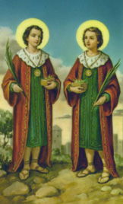

Sts. Cosmas and Damian - Feast Day 26th September

Brothers who had become eminent for their skill in the science

of medicine. Being Christians, they were filled with the spirit

of charity and never took money for their services.

Patron Saints of Pharmacists

